

Tourist Assistant Website

Software Requirement Specification

**Project Code: TAW**

**Document Code: TAW\_SRS – <v0.3>**

**Ha Noi, September 20th 2016**

Record of Change

\*A - Added M - Modified D - Deleted

|  |  |  |  |  |
| --- | --- | --- | --- | --- |
| Effective Date | Changed Items | A\* M, D | Change Description | New Version |
| 2016/09/20 | Create new | A | Create document | 0.1 |
| 2016/10/05 | Section 2.1 | M | Edit use case description | 0.2 |
| 2016/10/07 | Section 2.2,2.3,2.4 | A | Add | 0.3 |
|  |  |  |  |  |
|  |  |  |  |  |
|  |  |  |  |  |
|  |  |  |  |  |
|  |  |  |  |  |
|  |  |  |  |  |
|  |  |  |  |  |
|  |  |  |  |  |
|  |  |  |  |  |
|  |  |  |  |  |
|  |  |  |  |  |
|  |  |  |  |  |
|  |  |  |  |  |
|  |  |  |  |  |
|  |  |  |  |  |
|  |  |  |  |  |
|  |  |  |  |  |
|  |  |  |  |  |

Signature Page

**ORIGINATOR:** Nguyễn Xuân Thu Date: 2016/09/20

*Member*

**REVIEWERS:** Phan Thanh Tùng Date: 2016/09/23

*Member*

Chu Đại Cao Cường Date: 2016/10/05

*Member*

**APPROVAL:** Bùi Đình Chiến Date: 2016/09/25

*Supervisor*

Table of Contents

[Record of Change 2](#_Toc463549281)

[Signature Page 3](#_Toc463549282)

[Table of Contents 4](#_Toc463549283)

[Definitions and Acronyms 6](#_Toc463549284)

[1 Introduction 7](#_Toc463549285)

[1.1 Purpose 7](#_Toc463549286)

[1.2 Scope 7](#_Toc463549287)

[1.3 References 7](#_Toc463549288)

[2 System requirements Specification 8](#_Toc463549289)

[2.1 Functional requirements 8](#_Toc463549290)

[2.1.1 Use Case Diagram 8](#_Toc463549291)

[2.1.2 Business rule 10](#_Toc463549292)

[2.1.3 Register 11](#_Toc463549293)

[2.1.4 Log in 12](#_Toc463549294)

[2.1.5 Log out 13](#_Toc463549295)

[2.1.6 Search information 14](#_Toc463549296)

[*2.1.6.1* *Search place* 14](#_Toc463549297)

[*2.1.6.2* *Search user* 15](#_Toc463549298)

[*2.1.6.3* *Add suggest place* 16](#_Toc463549299)

[2.1.7 Manage profile 17](#_Toc463549300)

[*2.1.7.1* *Add new friend* 17](#_Toc463549301)

[*2.1.7.2* *Delete Friend* 18](#_Toc463549302)

[*2.1.7.3* *Send message* 19](#_Toc463549303)

[*2.1.7.4* *Change name* 20](#_Toc463549304)

[*2.1.7.5* *Change password* 21](#_Toc463549305)

[2.1.8 Manage place 22](#_Toc463549306)

[*2.1.8.1* *Add new favorite place* 22](#_Toc463549307)

[*2.1.8.2* *Delete favorite place* 23](#_Toc463549308)

[*2.1.8.3* *View friend profile* 24](#_Toc463549309)

[2.1.9 Manage blog 25](#_Toc463549310)

[*2.1.9.1* *Write a new post* 25](#_Toc463549311)

[*2.1.9.2* *Edit post* 26](#_Toc463549312)

[*2.1.9.3* *Comment to post* 27](#_Toc463549313)

[*2.1.9.4* *Delete a comment* 28](#_Toc463549314)

[*2.1.9.5* *Report a comment* 28](#_Toc463549315)

[*2.1.9.6* *Report blog* 29](#_Toc463549316)

[*2.1.9.7* *View post* 30](#_Toc463549317)

[2.1.10 Manage user 31](#_Toc463549318)

[*2.1.10.1* *Promote user* 31](#_Toc463549319)

[*2.1.10.2* *Ban user* 32](#_Toc463549320)

[*2.1.10.3* *Edit information of user* 33](#_Toc463549321)

[2.1.11 Manage suggest place 34](#_Toc463549322)

[*2.1.11.1* *List all suggest place* 34](#_Toc463549323)

[*2.1.11.2* *Confirm suggest place* 35](#_Toc463549324)

[*2.1.11.3* *Delete suggest place* 35](#_Toc463549325)

[2.1.12 Manage user’s report 36](#_Toc463549326)

[*2.1.12.1* *Show report list* 37](#_Toc463549327)

[*2.1.12.2* *View reported comment* 37](#_Toc463549328)

[*2.1.12.3* *View reported blog* 38](#_Toc463549329)

[*2.1.12.4* *Delete reported comment* 39](#_Toc463549330)

[*2.1.12.5* *Add new place* 40](#_Toc463549331)

[*2.1.12.6* *Send email service* 41](#_Toc463549332)

[*2.1.12.7* *Google street direction* 41](#_Toc463549333)

[*2.1.12.8* *Google tracking location* 42](#_Toc463549334)

[*2.1.12.9* *Login via Facebook account* 43](#_Toc463549335)

[2.2 Screen Prototype 44](#_Toc463549336)

[2.3 Non-Functional Requirements 4](#_Toc463549336)5

[2.3.1 Security 44](#_Toc463549337)

[2.3.2 Usability 45](#_Toc463549338)

[2.3.3 Reliability 45](#_Toc463549339)

[2.3.4 Performance 45](#_Toc463549340)

[2.3.5 Maintainability 45](#_Toc463549341)

[2.3.6 Extendibility 45](#_Toc463549342)

Definitions and Acronyms

|  |  |  |
| --- | --- | --- |
| Acronym | Definition | Note |
| TAW | Tourist Assistant Website |  |
| SRS | Software Requirement Specification |  |
| UC | Use Case |  |
| N/A | Not Available |  |

# Introduction

## Purpose

The main purpose of the requirement document is provides the information of the project from many perspectives. Readers can find out about the overview description or detail information in this document.

The information is the fully describing about the software system such as functional requirements, non-functional requirements, design constrains and any other necessary information.

This document is the software requirement specification of the project in order to develop the software, it includes two main parts: User Requirement Specification and System Requirements Specification:

* User Requirement Specification:
* Provides the general information about the software system.
* The project manager and supervisors should read this part because they can partly base on it to negotiate with each other about some particular problems.
* System Requirements Specification:
* Provides the detail information about the software system. This part captures the complete software requirements for the system, and then it is important for software designer, software developer, machine maker and manufacturer, tester and maintainer.
* This part is also for the project manager because it can help him to monitor all the activities of the project effectively.

## Scope

The document applies to many stages of developing the system:

* It is first used for project manager and supervisors to negotiate.
* It is also very important for designing, developing, manufacturing, testing and maintaining the system:
* The designers must know what the system is and what function it needs to have.
* The developing must know what the system does, how each function is implemented and the interface between components in system.
* The tester must know that to check if the system meets the requirements or not.

## References

**Document:**

1. VTT\_Report\_3\_SRS\_v0.1.pdf, Project Code: VTT, FPT University, Hanoi, Vietnam

# System requirements Specification

## Functional requirements

### Use Case Diagram

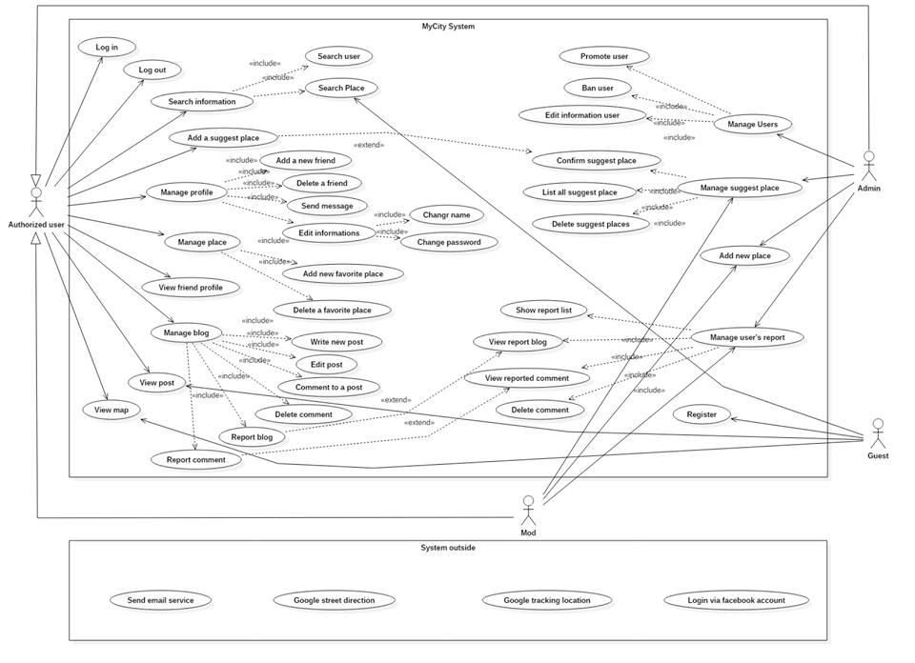

**FIGURE 2-1-1: Use Case Diagram**

TABLE 2-1-1: Use Cases list

|  |  |  |  |  |
| --- | --- | --- | --- | --- |
| **No** | **Use-case name** | | | **Use-case no** |
| 1 | Register | Register | | UC-01-01 |
| 2 | Log in | Log in | | UC-02-01 |
| 3 | Log out | Log out | | UC-03-01 |
| 4 | Search information | Search place | | UC-04-01 |
| 6 | Add a suggest place | Add a suggest place | | UC-05-01 |
| 10 | Manage profile | Edit information | Change name | UC-06-01 |
| 11 | Change password | UC-06-02 |
| 12 | Manage place | Add new favorite place | | UC-07-01 |
| 13 | Delete favorite place | | UC-07-02 |
| 14 | View user profile | View user profile | | UC-08-01 |
| 15 | Manage blog | Write new post | | UC-09-01 |
| 16 | Edit post | | UC-09-02 |
| 17 | Comment to a post | | UC-09-03 |
| 18 | Delete comment | | UC-09-04 |
| 19 | Report comment | | UC-09-05 |
| 21 | View post | View post | | UC-10-01 |
| 22 | Manage users | Promote user | | UC-11-01 |
| 23 | Ban user | | UC-11-02 |
| 24 | Edit information of user | | UC-11-03 |
| 25 | Manage suggest place | List all suggest place | | UC-12-01 |
| 26 | Confirm suggest place | | UC-12-02 |
| 27 | Delete suggest place | | UC-12-03 |
| 28 | Manage user’s report | Show report list | | UC-13-01 |
| 29 | View reported comment | | UC-13-02 |
| 31 | Delete comment | | UC-13-03 |
| 32 | Add new place | Add new place | | UC-14-01 |
| 33 | Send email service | Send email service | | UC-15-01 |
| 34 | Google street direction | Google street direction | | UC-16-01 |
| 35 | Google tracking location | Google tracking location | | UC-17-01 |
| 36 | Login via facebook account | Login via facebook account | | UC-18-01 |

### Business rule

TABLE 2-1-2: Business rule

|  |  |
| --- | --- |
| **No** | **Description** |
| B1 | “Full name” must not be blank. |
| B2 | “Full name” must be within 6-30 characters and must not contain special characters. |
| B3 | “Use name” must not be blank. |
| B4 | “Use name” must be within 6-30 characters and must not contain special characters. |
| B5 | “Password” must not be blank. |
| B6 | “Password” must be less than 8 characters. |
| B7 | “Email address” must not be empty. |
| B8 | “Email address” must contain character “.” and “@”. |
| B9 | “Birthday” must be before registration day. |
| B10 | The confirmation question must be matched. |
| B11 | “Password” must be correct. |
| B12 | The place must be not existed. |

### Register

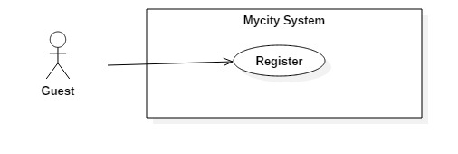

|  |  |  |  |
| --- | --- | --- | --- |
| Use Case ID: | UC-01-01 | | |
| Created By: | SyNH | Date Created: | 29/09/2016 |
| Primary Actor: | Guest | Secondary Actor: | N/A |
| Trigger: | Click on “Register” button. | | |
| Description | When you have just visited Mycity website, you are our guest and you can search places, view map, view blogs. But if you don’t have an account, you cannot use our outstanding features and many benefits such as: create profiles, keep in touch with friends, manage your favorite place, introduce new places, and show your experience with your blog… Mycity allows you to register an account with basic information (name, password, email, birthday …). And we instantly send you an email to confirm. When you have an account, you can login to Mycity and comfortably experience with our service. | | |
| Preconditions: | Guest has an email address. | | |
| Post conditions: | Mycity registers and send an email to user | | |
| Normal Flow: | Register:   1. The guest clicks on button “Register”. 2. The guest enters “Full name”, ”User name”, “Email address”, “ Password”, “Retype password”, “Gender”, “Birthday” and confirmation question. 3. The guest clicks on “Confirm” button 4. Mycity validates all the information, if it is correct, add user information to database and send an email to user’s email address with text: “Register successfully”. | | |
| Alternative Flows: | N/A | | |
| Exceptions: | N/A | | |
| Priority: | High | | |
| Frequency of Use: | Medium. | | |
| Business Rules: | B1, B2, B3, B4, B5, B6, B7, B8, B9, B10 | | |
| Other Information: | N/A | | |
| Assumptions | N/A | | |

### Log in

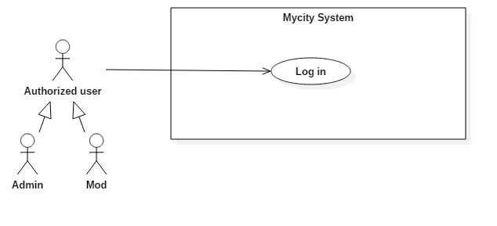

|  |  |  |  |
| --- | --- | --- | --- |
| Use Case ID: | UC-02-01 | | |
| Created By: | SyNH | Date Created: | 29/09/2016 |
| Primary Actor: | Authorized user | Secondary Actor: | Mod  Admin |
| Trigger: | Click on “Login” button. | | |
| Description | Whenever you visit Mycity website, we don’t identify you immediately. You have to prove you are an authorized user by login with registered account. You have to just enter exact username and password that you registered. After logged in successfully, you can access to your profile and use features: create profiles, keep in touch with friends, manage your favorite place, introduce new places, and show your experience with your blog … | | |
| Preconditions: | User has Mycity account. | | |
| Post conditions: | N/A | | |
| Normal Flow: | Log in   1. The actor clicks on “Login” button. 2. The actor enters: “User Name” and “Password”. 3. The actor clicks on “Login” button. | | |
| Alternative Flows: | N/A | | |
| Exceptions: | N/A | | |
| Priority: | High. | | |
| Frequency of Use: | High. | | |
| Business Rules: | B11 | | |
| Other Information: | N/A | | |
| Assumptions | N/A | | |

### Log out

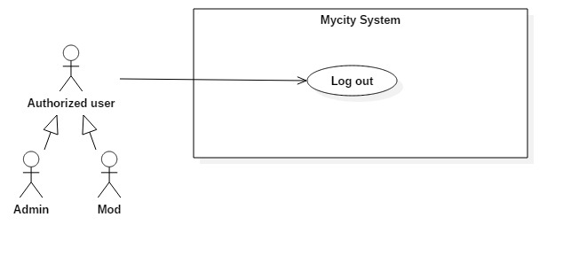

|  |  |  |  |
| --- | --- | --- | --- |
| Use Case ID: | UC-03-01 | | |
| Created By: | SyNH | Date Created: | 29/09/2016 |
| Primary Actor: | Authorized user | Secondary Actor: | Mod  Admin |
| Trigger: | Click on “Log out” button. | | |
| Description | After you have experienced the services of the website by using your personal account. Website help you log out to protect your personal information, information about the services to be used on the system and do not want others to use your account in order to use the services on the Mycity website. Or your relatives want to use you device to connect to Mycity but they want to use their account. After log out, you can login again with your account or other account. | | |
| Preconditions: | User is in Log in status. | | |
| Post conditions: | User is logged out Mycity. | | |
| Normal Flow: | Log out:   1. The actor clicks on “Log out” button. 2. The actor is logged out Mycity | | |
| Alternative Flows: | N/A | | |
| Exceptions: | System cannot end user’s session. | | |
| Priority: | Medium. | | |
| Frequency of Use: | Medium. | | |
| Business Rules: | N/A | | |
| Other Information: | N/A | | |
| Assumptions | N/A | | |

### Search information

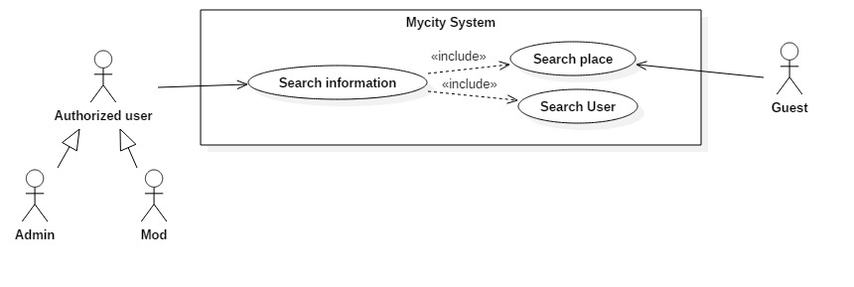

#### *Search place*

|  |  |  |  |
| --- | --- | --- | --- |
| Use Case ID: | UC-04-01 | | |
| Created By: | SyNH | Date Created: | 29/09/2016 |
| Primary Actor: | Authorized user | Secondary Actor: | Guest  Mod  Admin |
| Trigger: | N/A | | |
| Description | To prepare for traveling, you need to list the places to go and pick out interesting places. Website will help you with “Search places” function. "Search place" is one of the basic functions easy to see because it is located in the main view of website. Users can enter the name of the place you are looking for into the search box. Or you can select a list of locations through the Categories such as: cinema, club, sport... Immediately after the finish typing the keyword and click search, a list of all the locations corresponding to the keywords will is displayed on the screen for users to reference. | | |
| Preconditions: | N/A | | |
| Post conditions: | List all result matches with keyword. | | |
| Normal Flow: | I. Search place with keyword:   1. The actor enters key word into blank textbox. 2. The actor selects category to search. 3. The actor clicks on “Search” button. 4. Mycity lists all result matches with keyword.   II. Search place without keyword:   1. The actor selects category to search. 2. The actor clicks on “Search” button. 3. Mycity list all result match with category is selected. | | |
| Alternative Flows: | N/A | | |
| Exceptions: | Cannot get result match with keyword:   * Mycity displays an error message “ No result for this keyword” | | |
| Priority: | High. | | |
| Frequency of Use: | High. | | |
| Business Rules: | N/A | | |
| Other Information: | N/A | | |
| Assumptions | N/A | | |

### Add suggest place

#### *Add suggest place*

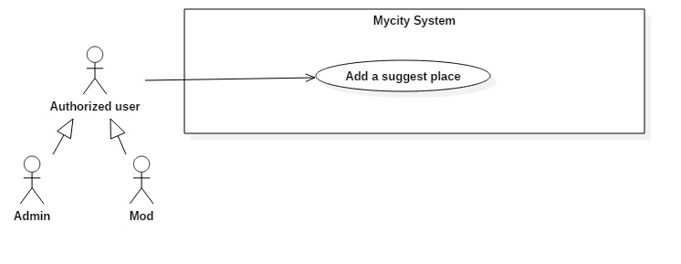

|  |  |  |  |
| --- | --- | --- | --- |
| Use Case ID: | UC-05-01 | | |
| Created By: | VietLT | Date Created: | 29/09/2016 |
| Primary Actor: | Authorized user | Secondary Actor: | Mod Admin |
| Trigger: | Authorized user needs to access to My city Website and then views the map. | | |
| Description | You've gone to the interesting places. You were impressed with the service there. Want to share this place to many people know or want to advertise your places. You can use "Add place" to do it. You need an account and login to website then you are able to use this function. You need to enter the full information about proposed location. Admin will check and if information of proposed location is accurate, it will be putted on the map for everyone. | | |
| Preconditions: | N/A | | |
| Post conditions: | Admin sends an email to confirm this suggest place. | | |
| Normal Flow: | I. Add a suggest place.  1. Authorized user clicks on task bar on the left side of upper corner.  2. Then clicks on “Map”.  3. In “Map” screen, authorized user clicks on “Add place”.  4. Authorized user continues to enter on “Place name”, “Latitude”, “Longitude”, and pick in “Categories”.  5. Then clicks on “Add” button.  6. If your place is invalid, My city will send an email to confirm. | | |
| Alternative Flows: | N/A | | |
| Exceptions: | N/A | | |
| Priority: | High | | |
| Frequency of Use: | High | | |
| Business Rules: | B12 | | |
| Other Information: | N/A | | |
| Assumptions | N/A | | |

### Manage profile

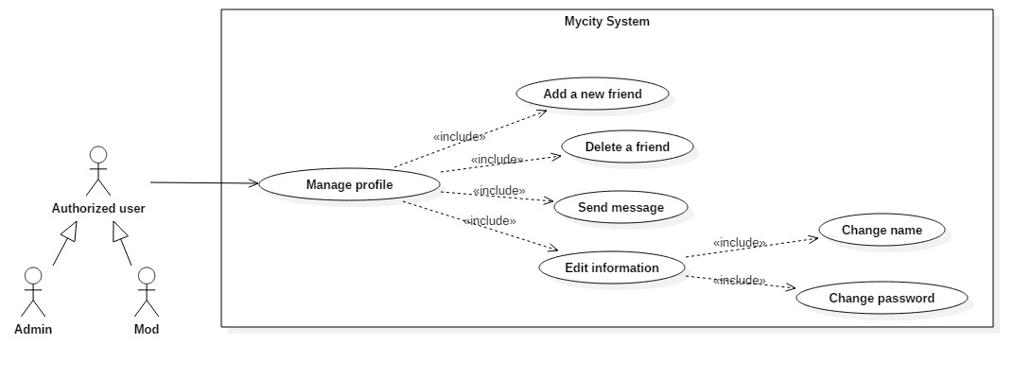

#### *Change name*

|  |  |  |  |
| --- | --- | --- | --- |
| Use Case ID: | UC-06-01 | | |
| Created By: | VietLT | Date Created: | 29/09/2016 |
| Primary Actor: | Authorized user | Secondary Actor: | Mod Admin |
| Trigger: | Authorized user needs to access to My city Website. | | |
| Description | You already have an account on Mycity website. When you register an account, you enter username in the Name field. For some reason you want to use other name to display on your profile. After successfully rename, the name displayed in the personal information will be updated with the name you want. | | |
| Preconditions: | N/A | | |
| Post conditions: | N/A | | |
| Normal Flow: | I. Change name.  1. Authorized user clicks on task bar on the left side of upper corner.  2. Then clicks on “User profile”.  3. In “User profile” screen, clicking on “Edit information”.  4. Then clicks on “Change your name”.  5. Enters your new name and clicks on “OK” button.  6. Your name which is displayed will be change. | | |
| Alternative Flows: | II. Authorized user wants to cancel the name change.  1. At step 5, the Authorized user clicks on “Cancel” button.  2. The name change will be cancel and your name which is displayed in your profile will be kept. | | |
| Exceptions: | N/A | | |
| Priority: | High | | |
| Frequency of Use: | Medium | | |
| Business Rules: | B1, B2, B3, B4 | | |
| Other Information: | N/A | | |
| Assumptions | N/A | | |

#### *Change password*

|  |  |  |  |
| --- | --- | --- | --- |
| Use Case ID: | UC-06-02 | | |
| Created By: | VietLT | Date Created: | 29/09/2016 |
| Primary Actor: | Authorized user | Secondary Actor: | Mod Admin |
| Trigger: | Authorized user needs to access to My city Website. | | |
| Description | Password is the mandatory requirement to help you login to Mycity Website. In addition it is help protect your accounts from those with malicious intent. You want to change the password because you fear someone know or you do not trust who already know your password or you simply want to replace one password to remember. This function will help you easily do that. | | |
| Preconditions: | N/A | | |
| Post conditions: | N/A | | |
| Normal Flow: | I. Change password.  1. Authorized user click on task bar on the left side of upper corner.  2. Then clicks on “User profile”.  3. In “User profile” screen, clicking on “Edit information”.  4. Then clicks on “Change your password”.  5. Enters your old password and new password and clicks on “OK” button.  6. Your password will be change. | | |
| Alternative Flows: | II. Authorized user wants to cancel the password change.  1. At step 5, the Authorized user clicks on “Cancel” button.  2. The password change will be cancel and your password will be kept. | | |
| Exceptions: | N/A | | |
| Priority: | High | | |
| Frequency of Use: | Medium | | |
| Business Rules: | B5, B6, B11 | | |
| Other Information: | N/A | | |
| Assumptions | N/A | | |

### Manage place

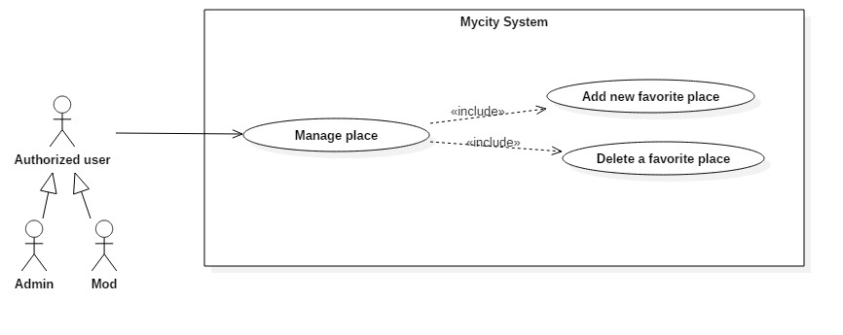

#### *Add new favorite place*

|  |  |  |  |  |  |  |
| --- | --- | --- | --- | --- | --- | --- |
| Use Case ID: | UC-07-01 | | | | | |
| Created By: | VietLT | | Date Created: | | 29/09/2016 | |
| Primary Actor: | Authorized user | Secondary Actor: | | Mod Admin | |
| Trigger: | Authorized user needs to access to My city Website. | | | | | |
| Description | When anyone travels, there is somewhere they are interested in and want to introduce to everyone such as: restaurant, hotel, and bar v.v. After login, website can help user note a place to be their favorite place. Favorite places will be displayed on personal map in the user profile. | | | | | |
| Preconditions: | N/A | | | | | |
| Post conditions: | N/A | | | | | |
| Normal Flow: | I. Add new favorite place.  1. Authorized user click on task bar on the left side of upper corner.  2. Then clicks on “Map”.  3. In “Map” screen, clicks on place icon which you want to add in favorite list.  4. In “Detail Information of place” screen, clicking on “Favorite”.  5. My city will add this place on “Map of favorite” in your user profile. | | | | | |
| Alternative Flows: | N/A | | | | | |
| Exceptions: | N/A | | | | | |
| Priority: | High | | | | | |
| Frequency of Use: | High | | | | | |
| Business Rules: | N/A | | | | | |
| Other Information: | N/A | | | | | |
| Assumptions | N/A | | | | | |

#### *Delete favorite place*

|  |  |  |  |
| --- | --- | --- | --- |
| Use Case ID: | UC-07-01 | | |
| Created By: | VietLT | Date Created: | 29/09/2016 |
| Primary Actor: | Authorized user | Secondary Actor: | Mod Admin |
| Trigger: | Authorized user needs to access to My city Website. | | |
| Description | After user added a place to favorite place, if user does not like this place anymore, they can delete this place in their favorite place in website. After that, user can still add this place to favorite place again if they want. | | |
| Preconditions: | N/A | | |
| Post conditions: | N/A | | |
| Normal Flow: | I. Add new favorite place.  1. Authorized user click on task bar on the left side of upper corner.  2. Then clicks on “Map”.  3. In “Map” screen, clicks on place icon which you want to add in favorite list.  4. In “Detail Information of place” screen, clicking on “Favorite”.  5. My city will add this place on “Map of favorite” in your user profile. | | |
| Alternative Flows: | N/A | | |
| Exceptions: | N/A | | |
| Priority: | High | | |
| Frequency of Use: | High | | |
| Business Rules: | N/A | | |
| Other Information: | N/A | | |
| Assumptions | N/A | | |

### View user profile

#### *View user profile*

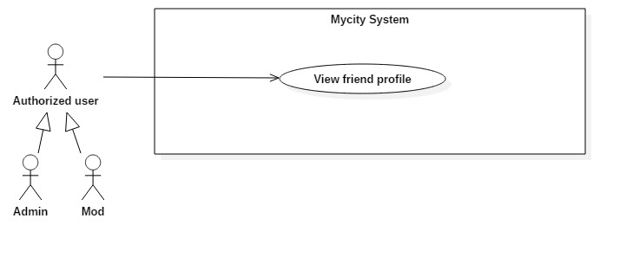

|  |  |  |  |
| --- | --- | --- | --- |
| Use Case ID: | UC-08-01 | | |
| Created By: | VietLT | Date Created: | 29/09/2016 |
| Primary Actor: | Authorized user | Secondary Actor: | Mod Admin |
| Trigger: | Authorized user needs to access to My city Website. | | |
| Description | Authorized user can view a user profile. Someone wants to find out some information about other people in order to communicate or sure with some information which is given by people whom they need view profile. | | |
| Preconditions: | N/A | | |
| Post conditions: | N/A | | |
| Normal Flow: | I. View friend profile.  1. Authorized user click on task bar on the left side of upper corner.  2. Then clicks on “User profile”.  3. In “User profile” screen,   1. The actor enter name of user into blank textbox.   The actor clicks on “Search” button.  4. Some information of user will be displayed. | | |
| Alternative Flows: | N/A | | |
| Exceptions: | N/A | | |
| Priority: | High | | |
| Frequency of Use: | High | | |
| Business Rules: | N/A | | |
| Other Information: | N/A | | |
| Assumptions | N/A | | |

### Manage blog

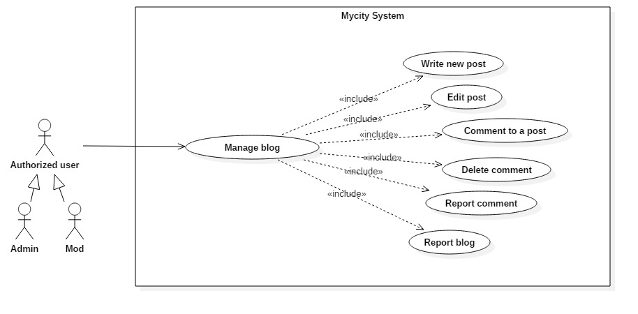

#### *Write a new post*

|  |  |  |  |
| --- | --- | --- | --- |
| Use Case ID: | UC-09-01 | | |
| Created By: | VietLT | Date Created: | 29/09/2016 |
| Primary Actor: | Authorized user | Secondary Actor: | Mod Admin |
| Trigger: | Authorized user needs to access to My city Website. | | |
| Description | When go to travel, anyone have many feelings about the place they traveled. If user want to show this, website help user can write a new post after login. Post is through a category, User can write description or review, and attach images about some place in post. | | |
| Preconditions: | N/A | | |
| Post conditions: | N/A | | |
| Normal Flow: | I. Write a new post.  1. Authorized user click on task bar on the left side of upper corner.  2. Then clicks on “Blog”.  3. In “Blog” screen, My city displays a Post creating form containing a text box of “Title”, a text area of “Description”, list of categories and an image attachment.  4. Authorized user fills in “Title”.  5. Authorized user gives some descriptions in “Description”.  6. Authorized user picks category of Post from list.  7. Authorized user also can attach some images.  8. Clicks on “Post”.  9. My city upload pictures to cloud and adds content of the Post to database.  10. My city displays the created Post to the news feed of Blog. | | |
| Alternative Flows: | II. Write a new post without Title and Description.  1. Return to step 1 with validation warning of missing field. III. Write a new post without Image.  1. Return to step 7 of Normal Flow. IV. Write a new post without picking category.  1. Return to step 6 of Normal Flow.  V. On the step 8 Authorized user clicks “Cancel” instead of “Post”.  1. Post creating form will be closed. | | |
| Exceptions: | N/A | | |
| Priority: | High | | |
| Frequency of Use: | High | | |
| Business Rules: | N/A | | |
| Other Information: | N/A | | |
| Assumptions | N/A | | |

#### *Edit post*

|  |  |  |  |
| --- | --- | --- | --- |
| Use Case ID: | UC-09-02 | | |
| Created By: | VietLT | Date Created: | 29/09/2016 |
| Primary Actor: | Authorized user | Secondary Actor: | Mod Admin |
| Trigger: | Authorized user needs to access to My city Website. | | |
| Description | Authorized user has just written a new post, but they found out some mistakes in this post or simply want to update some information about a place for that post. So website help user can edit their post. | | |
| Preconditions: | Authorized user must have at least one post in Blog. | | |
| Post conditions: | New information is updated successfully. All users can see this changed. | | |
| Normal Flow: | I. Edit post.  1. Authorized user click on task bar on the left side of upper corner.  2. Then clicks on “Blog”.  3. In “Blog” screen, My city displays all their posts  4. Clicks on post which you want to edit.  5. Click on “Edit Post”.  6. Authorized user can edit “Title”, “Description”, “Category”, and “Image”.  7. Authorized user clicks on “Save” button.  8. My city updated post successfully. | | |
| Alternative Flows: | II. Write a new post without Title and Description.  1. Return to step 6 with validation warning of missing field. III. Write a new post without Image.  1. Return to step 6 of Normal Flow.  IV. On the step 7 Authorized user clicks “Cancel” instead of “Save” .  1. Editing post form will be closed. | | |
| Exceptions: | N/A | | |
| Priority: | High | | |
| Frequency of Use: | High | | |
| Business Rules: | N/A | | |
| Other Information: | N/A | | |
| Assumptions | N/A | | |

#### *Comment to post*

|  |  |  |  |
| --- | --- | --- | --- |
| Use Case ID: | UC-09-03 | | |
| Created By: | VietLT | Date Created: | 29/09/2016 |
| Primary Actor: | Authorized user | Secondary Actor: | Mod Admin |
| Trigger: | Authorized user needs to access to My city Website. | | |
| Description | If user want to contribute information or give some feedback about post. After login, user can comment on their post or other user’s. | | |
| Preconditions: | N/A | | |
| Post conditions: | The number of post’s comments is incremented by 1. The new comment will be displayed in comment section. The Post’s owner is notified about the comment on his/her post. | | |
| Normal Flow: | I. Comment to a post.  1. Authorized user click on task bar on the left side of upper corner.  2. Then clicks on “Blog”.  3. In “Blog” screen, My city displays all their posts  4. Clicks on “View posts” to view other user’s posts.  5. Click on a post to view the Post Detail modal.  6. Authorized user writes in “Comment” text area.  7. Then clicks on “Post” button.  8. My city updated comment successfully and displayed the new comment in comment section.  9. My city system push notification to post’s owner. | | |
| Alternative Flows: | N/A | | |
| Exceptions: | N/A | | |
| Priority: | High | | |
| Frequency of Use: | High | | |
| Business Rules: | N/A | | |
| Other Information: | N/A | | |
| Assumptions | N/A | | |

#### *Delete a comment*

|  |  |  |  |
| --- | --- | --- | --- |
| Use Case ID: | UC-09-04 | | |
| Created By: | VietLT | Date Created: | 29/09/2016 |
| Primary Actor: | Authorized user | Secondary Actor: | Mod Admin |
| Trigger: | Authorized user needs to access to My city Website. | | |
| Description | After login and user commented in a post, if user does not like their comment anymore, they can delete this comment. | | |
| Preconditions: | N/A | | |
| Post conditions: | The number of post’s comments is decreased by 1. The new comment will be deleted from comment section. | | |
| Normal Flow: | I. Delete a comment.  1. Authorized user click on task bar on the left side of upper corner.  2. Then clicks on “Blog”.  3. In “Blog” screen, My city displays all their posts  4. Clicks on “View posts” to view other user’s posts.  5. Click on a post to view the Post Detail modal.  6. Authorized user clicks on the dropdown icon their one comment.  7. Then clicks on “Delete” button.  8. My city deletes this comment in comment section. | | |
| Alternative Flows: | N/A | | |
| Exceptions: | N/A | | |
| Priority: | High | | |
| Frequency of Use: | High | | |
| Business Rules: | N/A | | |
| Other Information: | N/A | | |
| Assumptions | N/A | | |

#### *Report a comment*

|  |  |  |  |
| --- | --- | --- | --- |
| Use Case ID: | UC-09-05 | | |
| Created By: | VietLT | Date Created: | 29/09/2016 |
| Primary Actor: | Authorized user | Secondary Actor: | Mod Admin |
| Trigger: | Authorized user needs to access to My city Website. | | |
| Description | Authorized user can report comment to admin that about illegal information, hate speech, violence .v.v. My city’s admin will check this report and reasonably handle. | | |
| Preconditions: | N/A | | |
| Post conditions: | Report is sent successfully to My city’s admin and My city’s admin shows popup to thank authorized user. | | |
| Normal Flow: | I. Report a comment.  1. Authorized user click on task bar on the left side of upper corner.  2. Then clicks on “Blog”.  3. In “Blog” screen, My city displays all their posts  4. Clicks on “View posts” to view other user’s posts.  5. Click on a post to view the Post Detail modal.  6. Authorized user clicks on the dropdown icon their comment.  7. Then clicks on “Report” button.  8. My city shows popup report to authorized user.  9. Authorized user enters report description about this target comment.  10. Then clicks on “Send” button.  11. My city sends this report to admin and shows popup to thank authorized user. | | |
| Alternative Flows: | II. Authorized user cancels report.  1. At step 10, authorized user clicks on “Cancel” button.  2. My city skips sending report and closes report popup. | | |
| Exceptions: | N/A | | |
| Priority: | High | | |
| Frequency of Use: | High | | |
| Business Rules: | N/A | | |
| Other Information: | N/A | | |
| Assumptions | N/A | | |

#### *View post*

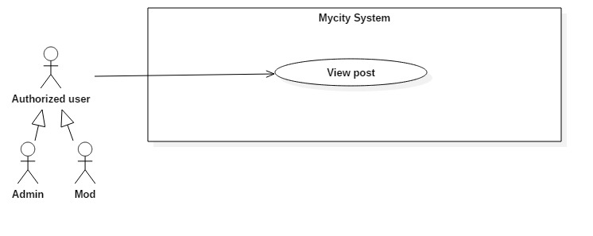

|  |  |  |  |
| --- | --- | --- | --- |
| Use Case ID: | UC-10-01 | | |
| Created By: | VietLT | Date Created: | 29/09/2016 |
| Primary Actor: | Authorized user | Secondary Actor: | Mod  Admin |
| Trigger: | Authorized user clicks on “Open post” | | |
| Description | After authorized user wrote posts. Other user can view that posts. | | |
| Preconditions: | Authorized user logged in My city account. | | |
| Post conditions: | N/A | | |
| Normal Flow: | I. View post:  1. Authorized user clicks on task bar on the left side of upper corner.  2. Then click on “Open post”.  3. My city shows all post. | | |
| Alternative Flows: | N/A | | |
| Exceptions: | N/A | | |
| Priority: | High | | |
| Frequency of Use: | High | | |
| Business Rules: | N/A | | |
| Other Information: | N/A | | |
| Assumptions | N/A | | |

### Manage user

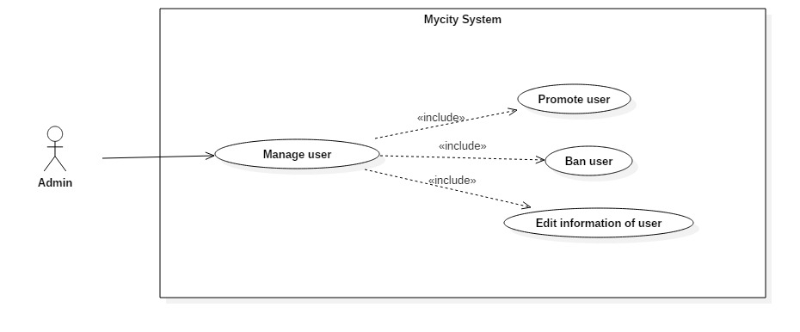

#### *Promote user*

|  |  |  |  |
| --- | --- | --- | --- |
| Use Case ID: | UC-11-01 | | |
| Created By: | VietLT | Date Created: | 29/09/2016 |
| Primary Actor: | Admin | Secondary Actor: | N/A |
| Trigger: |  | | |
| Description | Admin can promote authorized user who give particular contribution to the website and desiderate to build website to be mod. Mod has higher role in website. | | |
| Preconditions: | It must be admin account. | | |
| Post conditions: | N/A | | |
| Normal Flow: | Promote user:   1. Admin searches name of authorized user want to promote. 2. Admin click on promote icon. 3. Mycity display a message box “Do you want promote this member become a mod?” with 2 selections “Yes” and “No”.   Choose “Yes”   1. The authorized user is promoted, become a mod.   Choose “No”   1. Promote process is canceled. | | |
| Alternative Flows: | N/A | | |
| Exceptions: | N/A | | |
| Priority: | High | | |
| Frequency of Use: | High | | |
| Business Rules: | N/A | | |
| Other Information: | N/A | | |
| Assumptions | N/A | | |

#### *Ban user*

|  |  |  |  |
| --- | --- | --- | --- |
| Use Case ID: | UC-11-02 | | |
| Created By: | VietLT | Date Created: | 29/09/2016 |
| Primary Actor: | Admin | Secondary Actor: | N/A |
| Trigger: |  | | |
| Description | Admin can ban an authorized user who infringed terms such as who usually post or comment about illegal information, hate speech, violence .v.v. | | |
| Preconditions: | It must be admin account. | | |
| Post conditions: | N/A | | |
| Normal Flow: | Ban user:   1. Admin searches authorized user want to ban. 2. Admin clicks on Ban user icon. 3. Mycity displays ban user interface. 4. Admin set start day and finish day of banning. 5. Admin clicks on “Accept” button 6. Mycity displays a message box “Are you sure?” with 2 selections “Yes” and “No”   Choose “Yes”:   1. The account will be banished, cannot login to Mycity till expire the banning.   Choose “No”:   1. The banning is canceled. | | |
| Alternative Flows: | Cancel ban user:   1. Admin searches authorized user want to ban. 2. Admin clicks on Ban user icon. 3. Mycity displays ban user interface. 4. Admin set start day and finish day of banning. 5. Admin clicks on “Cancel” button. 6. The banning is canceled. | | |
| Exceptions: | N/A | | |
| Priority: | High | | |
| Frequency of Use: | High | | |
| Business Rules: | N/A | | |
| Other Information: | N/A | | |
| Assumptions | N/A | | |

#### *Edit information of user*

|  |  |  |  |
| --- | --- | --- | --- |
| Use Case ID: | UC-11-03 | | |
| Created By: | VietLT | Date Created: | 29/09/2016 |
| Primary Actor: | Admin | Secondary Actor: | N/A |
| Trigger: |  | | |
| Description | Admin can edit information of an authorized user who has information that is unreasonable in the rules. | | |
| Preconditions: | It must be admin account. | | |
| Post conditions: | N/A | | |
| Normal Flow: | Edit information of user   1. Admin clicks on user’s name want to change information. 2. Clicks on “Edit information”. 3. Redirect to edit user profile page. 4. After edit user’s information, admin clicks on “Accept” button to save user profile or “Cancel” to cancel editing user profile. | | |
| Alternative Flows: | N/A | | |
| Exceptions: | N/A | | |
| Priority: | High | | |
| Frequency of Use: | High | | |
| Business Rules: | N/A | | |
| Other Information: | N/A | | |
| Assumptions | N/A | | |

### Manage suggest place

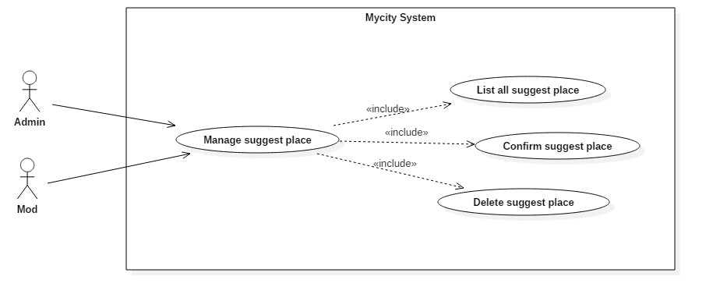

#### *List all suggest place*

|  |  |  |  |
| --- | --- | --- | --- |
| Use Case ID: | UC-12-01 | | |
| Created By: | SyNH | Date Created: | 29/09/2016 |
| Primary Actor: | Admin | Secondary Actor: | Mod |
| Trigger: | N/A | | |
| Description | After authorized user suggested place to admin. It will show suggest places list with the name, address of suggested places. Admin go to suggested places and check. | | |
| Preconditions: | Login as admin. | | |
| Post conditions: | N/A | | |
| Normal Flow: | Show suggest place list:   1. The actor clicks on “manage suggest place” button. 2. Mycity shows all suggest list on screen. | | |
| Alternative Flows: | N/A | | |
| Exceptions: | No suggest place to show:   1. Mycity displays a message “Cannot find any suggest place”. | | |
| Priority: | High. | | |
| Frequency of Use: | Medium. | | |
| Business Rules: | N/A | | |
| Other Information: | N/A | | |
| Assumptions | N/A | | |

#### *Confirm suggest place*

|  |  |  |  |
| --- | --- | --- | --- |
| Use Case ID: | UC-12-02 | | |
| Created By: | SyNH | Date Created: | 29/09/2016 |
| Primary Actor: | Admin | Secondary Actor: | Mod |
| Trigger: | N/A | | |
| Description | After authorized user suggested place to admin. Admin go to suggested places and check. After that, admin can accept suggested place from user, and add that place in the map. | | |
| Preconditions: | Have suggest place from authorized user | | |
| Post conditions: | The suggest place is added to the database. | | |
| Normal Flow: | 1. Confirm suggest place: 2. The actor clicks on “Manage suggest place” button. 3. The actor chooses a suggest place in the list. 4. The actor clicks on “Accept” button. 5. The place’s information is saved in database and set the location on the map. | | |
| Alternative Flows: | N/A | | |
| Exceptions: | The suggest place existed. | | |
| Priority: | High. | | |
| Frequency of Use: | Medium. | | |
| Business Rules: | B12 | | |
| Other Information: | N/A | | |
| Assumptions | N/A | | |

#### *Delete suggest place*

|  |  |  |  |
| --- | --- | --- | --- |
| Use Case ID: | UC-12-03 | | |
| Created By: | SyNH | Date Created: | 29/09/2016 |
| Primary Actor: | Admin | Secondary Actor: | Mod |
| Trigger: | N/A | | |
| Description | After authorized user suggested place to admin. Admin go to suggested places and check. If suggested place is not meeting the Mycity’s requirement, admin can delete suggested place. | | |
| Preconditions: | Exist at least 1 suggest place in suggest place list. | | |
| Post conditions: | N/A | | |
| Normal Flow: | 1. Delete a suggest place: 2. The actor clicks on “Manage suggest place” button. 3. The actor chooses a suggest place. 4. The actor click on “Delete” button. 5. Show a message “Are you sure?” with 2 selections “Yes” and “No”. 6. Choose “Yes”: 7. Click on button “Yes”. 8. The suggest place is deleted from suggest place list. 9. Choose “No”: 10. Click on button “No”. 11. The delete process is canceled. | | |
| Alternative Flows: | N/A | | |
| Exceptions: | N/A | | |
| Priority: | High. | | |
| Frequency of Use: | Medium. | | |
| Business Rules: | N/A | | |
| Other Information: | N/A | | |
| Assumptions | N/A | | |

### Manage user’s report

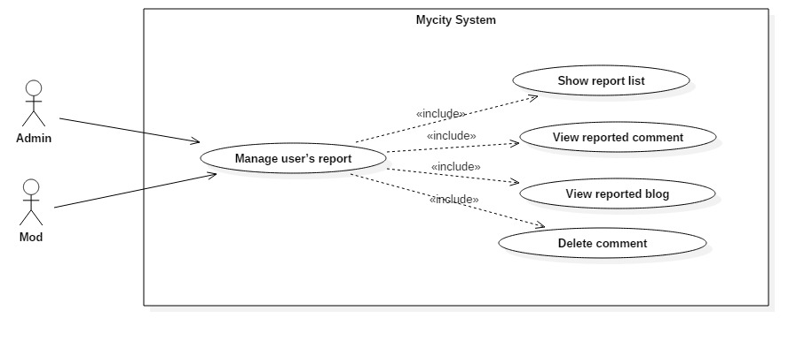

#### *Show report list*

|  |  |  |  |
| --- | --- | --- | --- |
| Use Case ID: | UC-13-01 | | |
| Created By: | SyNH | Date Created: | 29/09/2016 |
| Primary Actor: | Admin | Secondary Actor: | Mod |
| Trigger: | N/A | | |
| Description | After authorized user reported comment to Mycity that about illegal information, hate speech, violence. It will show report list from users for admin and mod. | | |
| Preconditions: | N/A | | |
| Post conditions: | N/A | | |
| Normal Flow: | Show report list:   1. The actor clicks on “Manage report”. 2. Mycity shows all report lists on the screen. | | |
| Alternative Flows: | N/A | | |
| Exceptions: | No report result:   1. Mycity displays a message “Cannot find any report”. | | |
| Priority: | High. | | |
| Frequency of Use: | Medium. | | |
| Business Rules: | N/A | | |
| Other Information: | N/A | | |
| Assumptions | N/A | | |

#### *View reported comment*

|  |  |  |  |
| --- | --- | --- | --- |
| Use Case ID: | UC-13-02 | | |
| Created By: | SyNH | Date Created: | 29/09/2016 |
| Primary Actor: | Admin | Secondary Actor: | Mod |
| Trigger: | N/A | | |
| Description | With reported comment list from users, admin and mod can view content of reported comment and reasonably handle. | | |
| Preconditions: | Exit at least 1 report comment in report list. | | |
| Post conditions: | N/A | | |
| Normal Flow: | View reported comment:   1. The actor clicks on “Manage report”. 2. Mycity show all report lists on screen. 3. The actor chooses a report about comment in the list. 4. The content of report is shown on screen. 5. The actor clicks con “Show” button to view content of comment. 6. Mycity show the content of comment on the screen. | | |
| Alternative Flows: | N/A | | |
| Exceptions: | The comment is deleted before the admin or mod views:   1. Mycity displays an error message box “Cannot find comment”. | | |
| Priority: | High. | | |
| Frequency of Use: | Medium. | | |
| Business Rules: | N/A | | |
| Other Information: | N/A | | |
| Assumptions | N/A | | |

#### *View reported blog*

|  |  |  |  |
| --- | --- | --- | --- |
| Use Case ID: | UC-13-03 | | |
| Created By: | SyNH | Date Created: | 29/09/2016 |
| Primary Actor: | Admin | Secondary Actor: | Mod |
| Trigger: | N/A | | |
| Description | With reported blog list from users, admin and mod can view content of reported blog and reasonably handle. | | |
| Preconditions: | Exit at least 1 reported blog in report list. | | |
| Post conditions: | N/A | | |
| Normal Flow: | View reported blog:   1. The actor clicks on “Manage report”. 2. Mycity show all report list on screen. 3. The actor chooses a report about blog in the list. 4. The content of report is shown on screen. 5. The actor clicks con “Show” button to view content of reported blog. | | |
| Alternative Flows: | N/A | | |
| Exceptions: | N/A | | |
| Priority: | High. | | |
| Frequency of Use: | Medium. | | |
| Business Rules: | N/A | | |
| Other Information: | N/A | | |
| Assumptions | N/A | | |

#### *Delete reported comment*

|  |  |  |  |
| --- | --- | --- | --- |
| Use Case ID: | UC-13-04 | | |
| Created By: | SyNH | Date Created: | 29/09/2016 |
| Primary Actor: | Admin | Secondary Actor: | Mod |
| Trigger: | N/A | | |
| Description | With reported comment list from users, admin and mod can view content of reported comment. If reported comments are about illegal information, nudity, hate speech, violence .v.v., admin and mod will delete that comment. | | |
| Preconditions: | The comment exists. | | |
| Post conditions: | N/A | | |
| Normal Flow: | 1. Delete a comment: 2. The actor chooses a comment which wants to delete. 3. The actor clicks on “Delete” button. 4. Mycity displays a message box “Are you sure delete this comment” with 2 selections “Yes” and “No”. 5. Choose “Yes”: 6. The actor clicks on “Yes” button. 7. Mycity delete selected comment. 8. Choose “No”: 9. The actor clicks on “No” button. 10. The delete process is canceled. | | |
| Alternative Flows: | N/A | | |
| Exceptions: | N/A | | |
| Priority: | High. | | |
| Frequency of Use: | Low. | | |
| Business Rules: | N/A | | |
| Other Information: | N/A | | |
| Assumptions | N/A | | |

### Add new place

#### *Add new place*

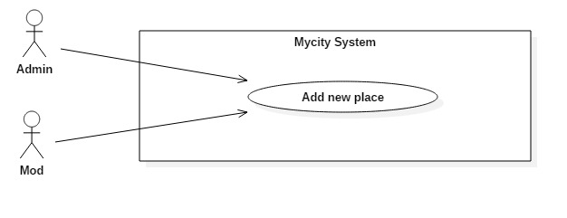

|  |  |  |  |
| --- | --- | --- | --- |
| Use Case ID: | UC-14-01 | | |
| Created By: | SyNH | Date Created: | 30/09/2016 |
| Primary Actor: | Admin | Secondary Actor: | Mod |
| Trigger: | N/A | | |
| Description | After check suggested places from user, admin and mod can add suggest places into the map or admin and mod add the place where they gone. | | |
| Preconditions: | The new place is not already existed. | | |
| Post conditions: | The information of new place is added into database. | | |
| Normal Flow: | Add new place:   1. The actor clicks on “Add new place” button. 2. Mycity display an “Add new place” interface. 3. The actor enter information of new place “Name”, “Address”, “Category”. 4. The actor set the new place into Mycity map. | | |
| Alternative Flows: | N/A | | |
| Exceptions: | N/A | | |
| Priority: | High. | | |
| Frequency of Use: | High. | | |
| Business Rules: | B12 | | |
| Other Information: | N/A | | |
| Assumptions | N/A | | |

### Send email service

#### *Send email service*

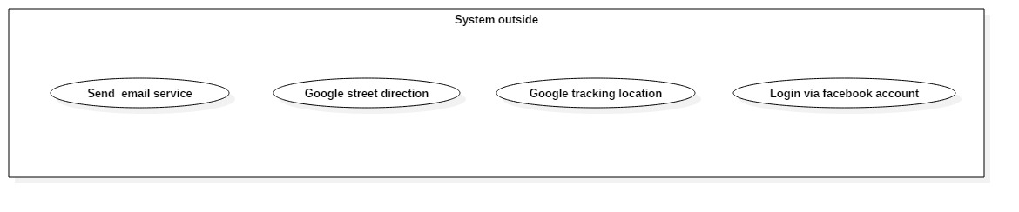

|  |  |  |  |
| --- | --- | --- | --- |
| Use Case ID: | UC-15-01 | | |
| Created By: | SyNH | Date Created: | 30/09/2016 |
| Primary Actor: | N/A | Secondary Actor: | N/A |
| Trigger: | N/A | | |
| Description | This service help Mycity system send email to user, notify about successful register or user’s suggest place is accepted. | | |
| Preconditions: | N/A | | |
| Post conditions: | N/A | | |
| Normal Flow: | Send email:   1. Service gets user’s email. 2. Service send an email to user with content “Register successfully” or “Your suggest place is accepted from admin”. | | |
| Alternative Flows: | N/A | | |
| Exceptions: | The user’s email is deleted. | | |
| Priority: | High. | | |
| Frequency of Use: | High. | | |
| Business Rules: | N/A | | |
| Other Information: | N/A | | |
| Assumptions | N/A | | |

### Google street direction

#### *Google street direction*



|  |  |  |  |
| --- | --- | --- | --- |
| Use Case ID: | UC-16-01 | | |
| Created By: | SyNH | Date Created: | 30/09/2016 |
| Primary Actor: | N/A | Secondary Actor: | N/A |
| Trigger: | N/A | | |
| Description | Guide way to go to target place from your current location. | | |
| Preconditions: | Already have user’s location. | | |
| Post conditions: | N/A | | |
| Normal Flow: | N/A | | |
| Alternative Flows: | N/A | | |
| Exceptions: | Cannot get current user’s location. | | |
| Priority: | High. | | |
| Frequency of Use: | High. | | |
| Business Rules: | N/A | | |
| Other Information: | N/A | | |
| Assumptions | N/A | | |

### Google tracking location

#### *Google tracking location*



|  |  |  |  |
| --- | --- | --- | --- |
| Use Case ID: | UC-17-01 | | |
| Created By: | SyNH | Date Created: | 30/09/2016 |
| Primary Actor: | N/A | Secondary Actor: | N/A |
| Trigger: | N/A | | |
| Description | Get the location of user to help street direction and suggested place around user. | | |
| Preconditions: | User must connect to an internet point. | | |
| Post conditions: | N/A | | |
| Normal Flow: | N/A | | |
| Alternative Flows: | N/A | | |
| Exceptions: | Can get user location | | |
| Priority: | High. | | |
| Frequency of Use: | High. | | |
| Business Rules: | N/A | | |
| Other Information: | N/A | | |
| Assumptions | N/A | | |

### Login via Facebook account

#### *Login via Facebook account*



|  |  |  |  |
| --- | --- | --- | --- |
| Use Case ID: | UC-18-01 | | |
| Created By: | SyNH | Date Created: | 30/09/2016 |
| Primary Actor: | N/A | Secondary Actor: | N/A |
| Trigger: | N/A | | |
| Description | A guest can login without account register on Mycity by use their Facebook account as a Mycity account. | | |
| Preconditions: | The actor must have a Facebook account. | | |
| Post conditions: | N/A | | |
| Normal Flow: | Login via facebook account:   1. The actor clicks on “Login” button. 2. Mycity displays login interface 3. The actor clicks on “Login via facebook” button. | | |
| Alternative Flows: | N/A | | |
| Exceptions: | N/A | | |
| Priority: | Medium. | | |
| Frequency of Use: | Medium. | | |
| Business Rules: | N/A | | |
| Other Information: | N/A | | |
| Assumptions | N/A | | |

## Screen Prototype

|  |  |  |  |
| --- | --- | --- | --- |
| No | Screen name | Screen no. | Associate Use-case |
| 1 | Home scream | TAW-SC-01 | UC-02-01, UC-03-01, UC-04-01 |
| 2 | Task bar screen | TAW-SC-02 | UC-02-01, UC-03-01, UC-10-01 |
| 3 | Log in screen | TAW-SC-03 | UC-01-01, UC-02-01, UC-18-01 |
| 4 | Register screen | TAW-SC-04 | UC-04-01, UC-05-01 |
| 5 | Map screen | TAW-SC-05 | UC-01-01 |
| 6 | Profile screen | TAW-SC-06 | UC-05-01, UC-06-04, UC-06-05, UC-07-01, UC-07-02 |
| 7 | Place list screen | TAW-SC-07 | UC-10-01 |
| 8 | Place detail | TAW-SC-08 | UC-09-02, UC-09-03, |
| 9 | Add place screen | TAW-SC-09 | UC-05-01 |

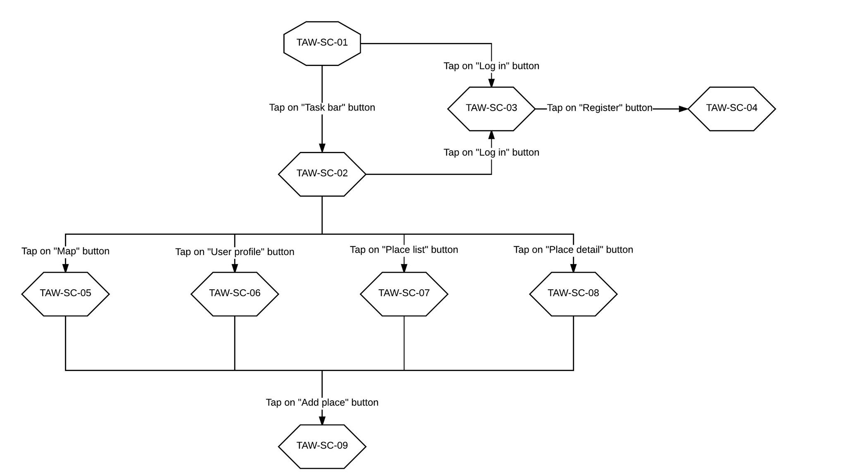

TAW Screen flow

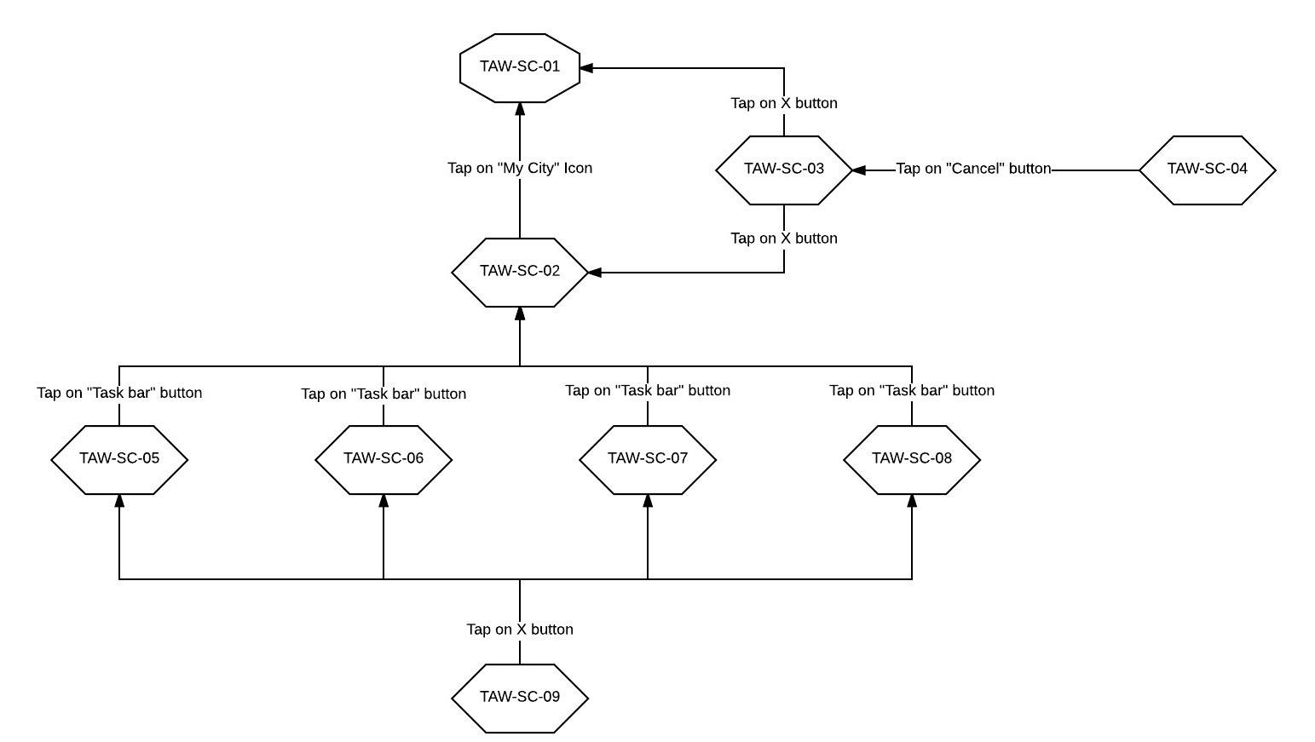

TAW Screen flow back

## Non-Functional Requirements

### Security

* Apply Authorize Attribute feature to the action methods.
* The security matrix is as the following table:

|  |  |  |  |  |
| --- | --- | --- | --- | --- |
| Function | Guest | Authorized Users | Mod | Admin |
| Register | ✓ |  |  |  |
| Log in |  | ✓ | ✓ | ✓ |
| Log out |  | ✓ | ✓ | ✓ |
| Search place | ✓ | ✓ | ✓ | ✓ |
| Search user |  | ✓ | ✓ | ✓ |
| Add a suggest place |  | ✓ | ✓ | ✓ |
| Change name |  | ✓ | ✓ | ✓ |
| Change password |  | ✓ | ✓ | ✓ |
| Add new favorite place |  | ✓ | ✓ | ✓ |
| Delete new favorite place |  | ✓ | ✓ | ✓ |
| View user profile |  | ✓ | ✓ | ✓ |
| Write new post |  | ✓ | ✓ | ✓ |
| Edit post |  | ✓ | ✓ | ✓ |
| Comment to a post |  | ✓ | ✓ | ✓ |
| Delete comment |  | ✓ | ✓ | ✓ |
| Report comment |  | ✓ | ✓ | ✓ |
| View post |  | ✓ | ✓ | ✓ |
| Promote user |  |  |  | ✓ |
| Ban user |  |  |  | ✓ |
| Edit information user |  |  |  | ✓ |
| List all suggest place |  |  | ✓ | ✓ |
| Confirm suggest place |  |  | ✓ | ✓ |
| Delete suggest place |  |  | ✓ | ✓ |
| Show report list |  |  | ✓ | ✓ |
| View reported comment |  | ✓ | ✓ | ✓ |
| Delete reported comment |  |  | ✓ | ✓ |
| Add new place |  |  | ✓ | ✓ |
| Send email service |  |  |  |  |
| Google street direction |  |  |  |  |
| Google tracking location |  |  |  |  |
| Login via facebook account |  |  |  |  |

### Usability

* Easy to understand and use website without training.
* Graphic user interface friendly: big size font text, little item, harmonious color.
* The map must be easy to view. It does not display too many place item when user zoom in the map.

### Reliability

* The output should avoid conflicting and misleading outputs when the inputs are confusing.
* Mean time to recover: In the case of failure, system should be able to recover within one day.
* Server have back-up method to make sure that if it have problem while running then all necessary data must be protected and restore as soon as possible.
* Server should be available 24/7 standby to serve user requests except the time of maintenance and upgrade.

### Performance

* Server response time is under 200 ms.
* Send the result after searching in 3-5 seconds.

### Maintainability

* The system is divided into separated modules.
* Output of project must include coding standards and naming convention documentations.
* The data should be easily to maintain over time. When update data, the source code does not need to be changed.
* Limit hard code as possible.

### Extendibility

Since nowadays a lot of people have at least one smartphone. So that, in the future we want to develop this as mobile application to more convenience when using our system while walk around the city. Moreover, if this website is success, we will be able to develop a larger system with extended scope to whole of Vietnam country.

## Database Requirements

## C:\Users\cuong\Desktop\Project2016\Report 2\ERD&System_diagram\ERDDiagram1.jpg